Where were you when…?

The Day MJ Died
Compare your text with mine. Circle any differences, DON’T CHANGE YOUR VERSION.
I was at a festival when I heard that Michael Jackson had died. It was about 3 in the morning and we were sitting in one of the big tents listening to music, drinking and chatting. Suddenly we overheard a guy sitting next to us saying that Michael Jackson had taken an overdose and had died. We thought it couldn’t possibly be true and carried on as before, but then the DJ played Beat it by Michael Jackson, then Billy Jean and then more and more of his songs, we all looked at each other, everyone in the tent realised that it must be true and we all stood up and danced.
Guided Questions:
- There are three different past tenses in the text, can you identify them?
- Which tense do we use to give a description of a scenario or scene at a specific time?
- Which tense do we use to say that an action happened before another action?
- Which tense do we use to describe short actions often in sequence?
- How do we form the past continuous? Subject + __________ + ___________
- How do we form the past perfect? Subject + __________ + ___________
- This is a contracted sentence: “Michael Jackson’d taken an overdose.” What is the complete version?

Practice
Complete the text with the correct verb tense.
The Day the Towers Came Down.
I was at school when I ______(hear) that terrorists __________(attack) the World Trade Centre. I _________ (stand) outside the school gates ________ (wait) for the school bus and ________(chat) to my friends when suddenly one of the teachers __________(run) out of the school and ________(tell) us that something terrible ____________(happen) in New York. Two planes _________(crash) into the twin towers in New York, when I _________(get) home I __________(watch) the towers collapse on the news with my parents. I’ll never forget where I was that day.

Your Turn
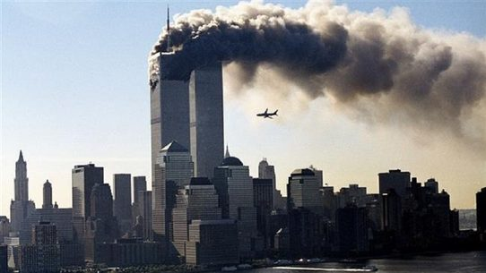 | Where were you when you heard about 9/11?
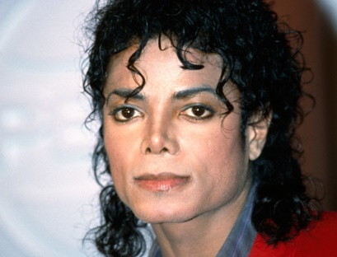 | Where were you when you heard MJ had died?
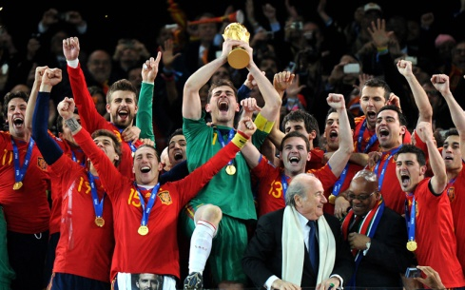 | Where were you when Spain won the world cup?
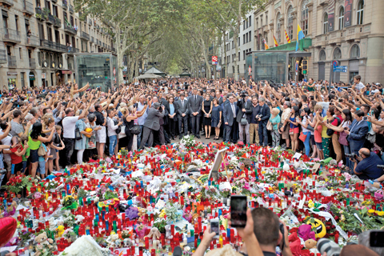 | Where were you when you heard about the terrorist attack on La Rambla?
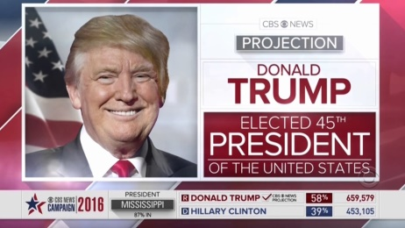 | Where were you when you heard Donald Trump had been elected president?

